Progress Report
Affect in the Poetry of Emily Dickinson
Trevor Kearns, Ian Torres
CS 585, Fall 2017

Dataset
We are working with the entire set of 1,775 poems written by Emily Dickinson as published in the 1955 variorium edition of her poetry, edited by Thomas H. Johnson [1]. Dickinson’s work is difficult for many reasons, not least of which is the variations with which it has been published in the nearly century and a half after her death. Most of her poems were discovered by her sister after she died, tied together with ribbons in little packets Dickinson referred to as “fascicles.” While she published only a handful of poems during her lifetime, and shared many more in private letters with friends and family, the complete set of her poems only became generally available with the Johnson edition in the mid-1950s. Several shorter editions of several hundred poems apiece were published before then, allowing Dicknison’s work to begin influencing other writers, but these editions presented a distorted picture of her work; their editors added titles (with very rare exceptions, Dickinson did not title her poems), normalized her eccentric lineation and punctuation (Dickinson is almost unique among English writers for her reliance on dashes in lieu of regular punctuation and idiosyncratic capitalization of common nouns), and arranged her poems in thematic groups that Dickinson clearly had not intended for the presentation of her work.
Johnson’s variorium edition was the first to restore her original stylistic choices, strip away the added titles, and number the poems according to Johnson’s best judgment of their chronological composition. This ordering will forever be unknown with absolute precision since Dickinson did not track the date of writing for all poems, and scholars, including those who disagree with Johnson’s numbering, must all base their work on data such as handwriting style, correlation with life events, and dated revisions, along with a certain degree of guesswork. Rather than venture into this controversy, we are simply assuming that Johnson’s numbering is broadly accurate over the span of Dickinson’s life.
As it is all in the public domain, Dickinson’s work was easy to obtain, but more difficult to prepare for NLP. The digital version of the Johnson edition is riddled with inaccuracies, including words normalized incorrectly by a spell-checker and poems run together without intervening numbers indicating a new poem has started (a group of ten such poems being the most egregious example). We compared the digital version of each poem with a correctly formatted PDF in order to correct these problems. Also, in the cases where more than one version of a poem is included in the Johnson edition, we have opted to only include the first version in our dataset for simplicity’s sake. Finally, for baseline testing, we removed all punctuation aside from apostrophes (used mainly in the usual contractions such as you’re and I’m as well as in now-archaic expressions like ‘twas and e’en) and converted poems to lowercase.
Along with the poetic corpus, we used the SentiWordNet 3.0 lexicon [2], which provides negative and positive values for the WordNet corpus (117,000 synsets), to create affect scores for Dickinson’s poems. The poetic corpus of 1,775 poems contains 10,933 unique tokens and 94,424 total tokens. We designated 300 poems drawn from a random uniform distribution as a test set, and we read and annotated all of these with primary and secondary thematic tags. The tag set at this point consists of the following: {'insects', 'connection', 'death', 'mother', 'madness', 'art', 'mind', 'falsehood', 'wonder', 'family', 'scorn', 'privacy', 'determination', 'spring', 'love', 'frustration', 'hesitation', 'time', 'sadness', 'loss', 'fame', 'seasons', 'life', 'sleep', 'disconnection', 'freedom', 'happiness', 'mystery', 'woman', 'salvation', 'imagination', 'fear', 'beauty', 'trees', 'peace', 'marriage', 'weather', 'sickness', 'friendship', 'suffering', 'work', 'winter', 'smallness', 'children', 'surprise', 'summer', 'flowers', 'birds', 'nature', 'science', 'memory', 'grace', 'faith', 'autumn'}. This tagset will be refined (possibly condensed), and we plan to review the tags for the test set.

Baseline Affect Scores
We originally planned to assign affect scores (AS) to each line in a poem as well as to each poem overall, calculating the latter by combining the affect score for a sentence in some way with the scores of the lines over which it broke. This would be an attempt to quantify the affective effect of the tension that exists naturally between individual verses and the larger syntactic units in which they participate, an effect that poets control and modulate as part of their essential techniques. However, two difficulties made this plan unworkable: often, Dickinson writes in a way that leaves the relation between line and syntactic unit ambiguous (so that a reader must interpret arbitrarily where sentences might begin or end), and the mathematical relation between line affect and sentence affect is inherently undefined, so that any combination of the two would again be founded on arbitrary assumptions.
Furthermore, our original intent was to make use of a dimenstional representation of affect in order to capture more of the breadth of emotional nuance inherent to poetry, but we were unable to acquire the code necessary for a dimensional representation. Doing so would allow for a much finer-grained analysis of affect, one unfortunately beyond the scope of our project this semester.
To overcome all these difficulties, we opted instead to use the positive and negative sentiment scores in SentiWordNet 3.0 for overall poem scores. For the baseline, we did not filter tokens in the poetry by synset, but did a direct lookup, subtracting the negative from the positive score for each matched token, then averaging over two values to calculate two different affect scores: a “stripped” score (averaged over the total tokens matched) and a “pure” score (averaged over total word count for the poem). These can be thought of as affect densities for each poem; the stripped score is more useful for comparing the affective cores of poems (within this corpus or against another poet’s corpus), while the pure score offers more information about the typical style of an individual poet (for example, Dickinson’s style is notoriously compressed, packing a lot of meaning into a small number of words and often omitting elementary syntactic words, thus forcing readers to digest her work slowly and with difficulty). We hope that in the future, this pure score will help us build a classifier to predict whether a poem was written by Dickinson or not. These scores do not currently generate different predictions for any given poem, but they might once we incorporate several refinements to the calculation process (see below).
To test the validity of this baseline, we chose 40 poems at random from our test set of 300 (also randomly chosen uniformly from across the corpus). We both read and predicted affect for these poems independently, then compared our results with the baseline counting. We agreed 80% of the time (32/40 poems), a figure that rises to 90% if we remove divergent readings for particularly ambiguous poems (120, 467, 471, and 702). Given the subjectivity with which poetry must be interpreted in general, and the difficulties particular to Dickinson’s work, we consider these to be acceptable agreement rates, and worth aiming for as we refine our representation of affect in these poems.
Table 1: Comparison of Human Affect and AS Baseline Predictions. Green indicates complete agreement, yellow mixed results between human and algorithm, and red disagreement between human and algorithm. Blue poems are particularly ambiguous in terms of affect.
As seen in Table 1, the baseline representation is on par with random prediction (53.1% agreement rate with poems on which we agreed, 17/32; discounting ambiguous poems 269, 294 and 340, this rises to 17/29, or 58.6% agreement), so clearly there is much room for improvement in how we calculate affect scores. First, however, we used these baseline scores to analyze the corpus.

Baseline Analysis of Corpus
To get an overview of Dickinson’s affective predilections, we generated histograms of simple positive/negative scores (pos ≥ 0, neg < 0) and bins with size 0.025. Stripped AS scores were used.
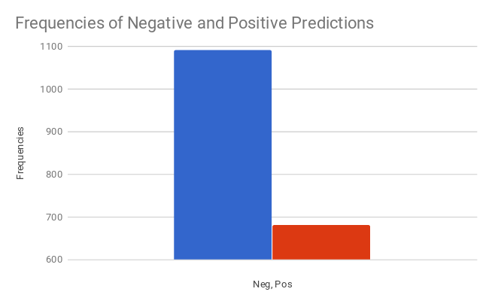
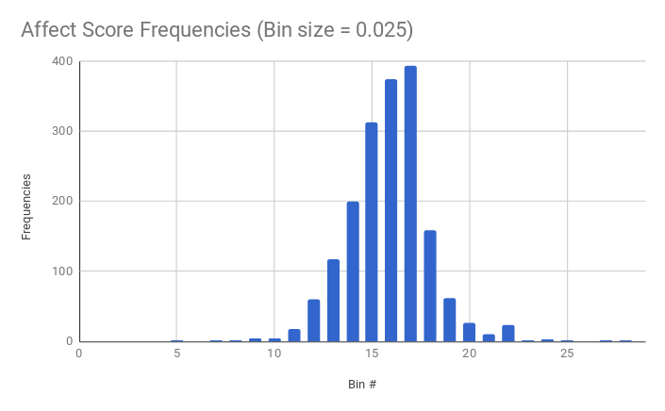
The three highest-scoring bins (15, 16, and 17) have the following respective ranges: [-0.05, -0.025), [-0.025, 0), [0, 0.025]. The average stripped AS for the corpus is -0.01675, while the average pure AS is -0.00891. This slight preference for negative affect correlates broadly with favored themes sampled from the 300-poem test set: the top five themes by summing frequencies of primary and secondary instances are wonder (54 total), death (52), loss (41), suffering (34), and nature (34). Note that wonder here incorporates both ecstatic and overawed responses to pheonomena, so it is an ambivalent category from an affective standpoint, while death, loss, and suffering are exclusively negative.
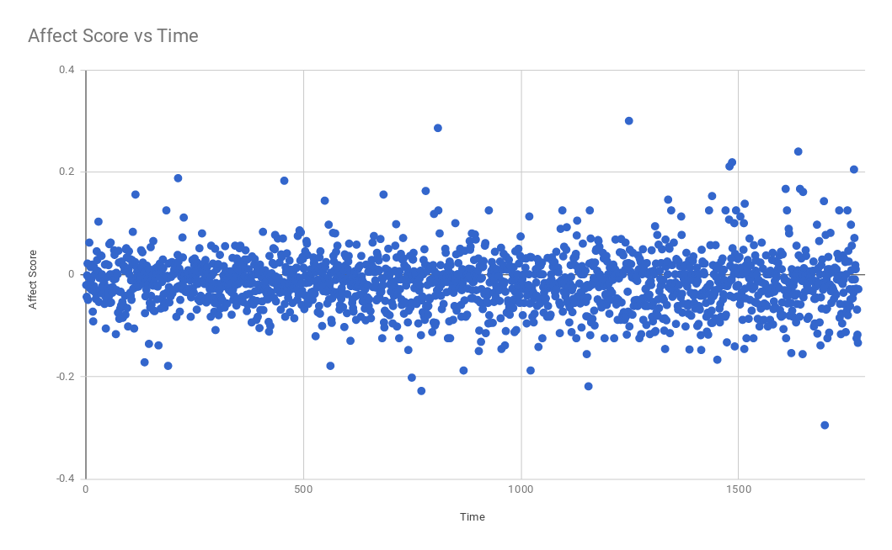
Also, since these poems have been numbered by hypothesized chronology, we are able to check if Dickinson’s affective preference underwent significant shifts over time:
At this point, it does not appear so, but improved AS might

Planned Improvements

*POS filtering*: each word gets a POS tag from a parser, that POS tag is used for the SentiWordNet lookup
*synset filtering*: each unigram and bigram is also passed through synset filter (in WordNet) to shuffle it into the right "sentiment bin"; this should give us a lot more scores from SentiWordNet. I doubt we'll wind up with zero-valued poems then. with these scores, we'll get an improved basic-AS-adding approach.
*PMI from pos/neg seed lists*: this ought to be our top-shelf approach. we have the seed lists generated already; we'll pass those through synset filter to look up base SentiWordNet scores, then calculate PMI for every word in corpus in relation to seed lists, then tabulate PMI scores per poem for refined AS. we can then compare with earlier results to see if we've improved accuracy.
*classifier*: what should I put down for this? maybe we annotate a lot more ED poems for pos/neg, then compare results of using these three different ways of calculating AS to see if we improve accuracy?

The progress report is a 5-10 page document that describes your preliminary work and results. You should do and report on work including

- The report must contain at least one table or graph that conveys numerical information – for example, statistics about your data or annotations, accuracy or other results of running an algorithm on the data, or something else.
- You now have a better idea of how much you can accomplish in the rest of the semester. Lay out the major items you want to accomplish. Provide a timeline to finish them by.

Works Cited
[1] E. Dickinson, Poems of Emily Dickinson; Including Variant Readings Critically Compared with All Known Manuscripts, ed. Thomas H. Johnson, Harvard UP, Cambridge, 1955, Vols. I-III.

[2] S. Baccianella, A. Esuli, and F. Sebastiani, "SentiWordNet 3.0: An Enhanced Lexical Resource for Sentiment Analysis and Opinion Mining," In LREC, vol. 10, pp. 2200-2204. 2010.

[3]

